GRADE 7 FIGURES OF SPEECH VISUAL DICTIONARY
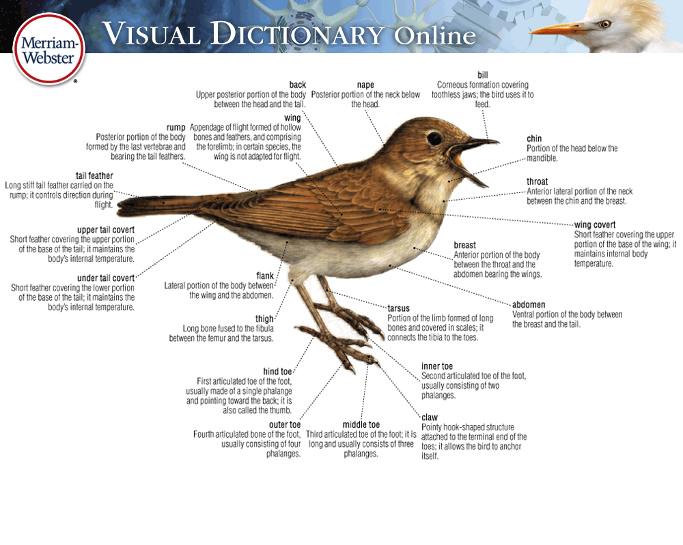
A visual dictionary is a dictionary that has been illustrated with diagrams that help support and explain the definitions of the words.

For this assignment, you are going to create a visual dictionary for the figures of speech we will be studying in class. There is a written component and a visual component:
- Written - you will be creating a page for each figure of speech. Each page will include the definition and an example of the figure of speech.
- Visual – each page will also have a visual representation of the figure of speech example.

Figures of Speech you will need to include:

- Imagery
- Simile
- Metaphor
- Alliteration
- Personification
- Onomatopoeia
- Hyperbole
- Idioms

ASSIGNMENT CHECKLIST – “My Visual Dictionary…”

THE WRITTEN COMPONENT
- … each page has a figure of speech as its title.
- … each page has the definition of the figure of speech.
- … has an original example for each figure of speech.
- … has been edited by you and a friend (spelling, grammar, punctuation).
THE VISUAL COMPONENT
- … has a creative title page.
- … has a relevant picture, or a nice design on the title page.
- … each page has a picture that visually represents each example.
- … has all been coloured.
- … is neat and tidy.
- … makes good use of each page space.
- … is school appropriate.
- … IS SOMETHING I’M PROUD OF!

ASSIGNMENT DUE DATE
TO BE DETERMINED AS A CLASS
ASSIGNMENT IS DUE ON ________________________________

 | 4 | 3 | 2 | 1
Time Management and Effort  Stem 3: Manages and Evaluates information and ideas. | Time has been used effectively every class. It’s obvious that a great deal of time and effort went into the design. | Time has been used effectively most classes. Time and effort was spent on the design. | Time has been used somewhat effectively. Student was sometimes off task. More time and effort could have been spent on the design. | Time has not been used effectively. Student was off task most classes. The design shows little time and effort.
Creativity / Content  Stem 2: Writes to develop, organize and express information and ideas.  Stem 5: Constructs meaning and makes connections through listening.  Stem 6: Represents ideas and creates understanding through a variety of media. | Figure of speech examples and visuals are exceptionally creative, original, detailed, and are a strong and correct representation of the figure of speech. | Figure of speech examples and visuals are creative, original, and are a strong and correct representation of the figure of speech. | Figure of speech examples and visuals are sometimes creative, but may be lacking details or originality. Most examples are a strong and correct representation of the figure of speech. | Figure of speech examples and visuals are not creative, or original. Many examples are not a proper representation of the figure of speech.
Neatness /Organization  Stem 3: Manages and evaluates information and ideas. | Overall, the dictionary is exceptionally neat and carefully completed. The design is organized, creative, and colourful.  All elements are present (titles, definitions, examples, visuals). | Overall, the dictionary is neat. The design is organized and visually appealing.  All elements are present (titles, definitions, examples, visuals). | Overall, the dictionary is lacking some neatness. The design is acceptable, but lacks organization and effort.  All elements are present (titles, definitions, examples, visuals). | Overall, the dictionary is distractingly messy. The design is disjointed and/or seriously lacking effort.  Some elements are missing (titles, definitions, examples, visuals).
Writing Mechanics  Stem 2: Writes to develop, organize and express information and ideas. | The written portion of the assignment has no errors in spelling, punctuation, or grammar. The work has clearly been edited. | The written portion of the assignment has few errors in spelling, punctuation, or grammar, which do not take away from the quality of the work. The work has clearly been edited. | The written portion of the assignment has errors in spelling, punctuation, or grammar. The work may not have been edited. | The written portion of the assignment has a distracting amount of errors in spelling, punctuation, or grammar. The work was clearly not edited.
Visual Component  Stem 6: Represents ideas and creates understanding through a variety of media. | The visual is a strong representation of the figure of speech. The image is exceptionally creative, detailed, and perfectly illustrates the example. | The visual is a good representation of the figure of speech. The image is creative, detailed, and illustrates the example. | The visual represents the figure of speech, but may be missing some subtle elements. The image is creative, and illustrates the example. | The visual does not properly represent the figure of speech.

