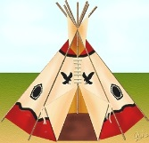
HOUSE of LEARNING:
Grade Seven Team
Introduction:
Throughout the year there will be many times when the curriculum between one core subject relates to that of another. Recently, students have been learning about the Aboriginal Peoples of Canada and how they used the natural environment to survive and build their dwellings. Within the science unit “Structures and Forces”, students have also been learning about the various types of structures that are used to meet our society’s needs and wants. Whether that be of mass, shell or frame structure. Throughout this project, students will incorporate the content learned about present day structures and how it relates to the dwellings of the Aboriginal peoples.

Project Requirements:
Students are expected to build their Aboriginal dwelling based on their assigned first nations group. They are to build that dwelling with a variety of materials provided within the classroom. If they choose to bring materials from home they are more than welcome too. Once they have researched their Aboriginal dwelling, they are to construct the frame and create the walls of that dwelling. The information about various structure types, Aboriginal dwellings and how they relate must be presented on the walls of their home. The information provided, must also include the various forces that may have an impact upon the home that they construct (compression, tension, torsion etc.).
This information can be presented in a variety of ways….use your imagination!

HAVE FUN!

HOUSE of LEARNING 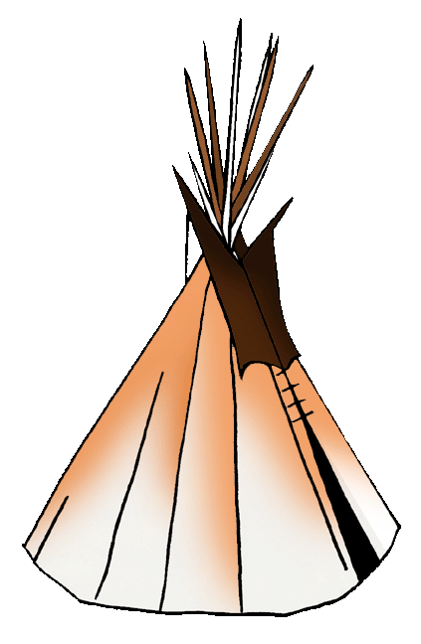
STUDENT PLANNING SHEET

Instructions:

- Determine your group, four or five members. Remember to choose people you work well with, as you will share the mark!!
Group Members: I) ____________________________
II) ____________________________
III) ____________________________
IV) ____________________________
V) ____________________________
Vl) ____________________________

2. Develop and detail a group contract highlighting each member’s responsibilities, materials they will contribute and all deadlines. Have each group member sign the contract, date and submit the final contract copy to your teacher.

Group contract draft/ideas:
________________________________________________________________________________________________________________________________________________________________________________________________________________________________________________________________________________________________________________________________________________________________________________________________________________________________________________________________________________________________________________________________________________________________________________________________________________________________________________________________________________________________________________________________________________________________________________________________________________________________________________________________________________________________________________________________________________________________________
3. Draw a detailed rough draft of your prototype, including symbols, pictographs etc. (You may use any computer program to create this design or just draw it). Create a unique name/design/for your dwelling?
SHOW THIS TO YOUR TEACHER FOR APPROVAL.

Rough Design: Name/Symbol: ______________________________

Teacher Approval: _____________________ Date: ___________

4. Questions to be answered and included on the walls of your prototype (model). Please explain in full detail.

a. What was the purpose of your dwelling? ________________________________________________________________________________________________________________________________________________________________________________________________________________________

b. How did this design fit your First Nations daily life?
________________________________________________________________________________________________________________________________________________________________________________________________________________________

c. Why and when was this design used?
________________________________________________________________________________________________________________________________________________________________________________________________________________________

d. How did this design inspire structures used today? Have the environment impacts changed with respect to structure design?
________________________________________________________________________________________________________________________________________________________________________________________________________________________

e. What are the three types of structures that we learned about in Science class and what type of structure is your dwelling? What are the advantages and disadvantages of this structure based upon where your first nations lived?
________________________________________________________________________________________________________________________________________________________________________________________________________________________________________________________________________________________________

f. What were some of the forces that acted upon the dwelling and how was the dwelling designed to help withstand these forces? Think about design and location of your first nations group.
________________________________________________________________________________________________________________________________________________________________________________________________________________________

5. What were the aspects of design that your Aboriginal group had to take into consideration and why?
________________________________________________________________________________________________________________________________________________________________________________________________________________________

6. What type(s) of fasteners did your Aboriginal group use to help support their dwellings? Why?
________________________________________________________________________________________________________________________________________________________________________________________________________________________

7. List all the materials required (Materials used should be displayed on your wall). Include things such as glue guns, hammer, screws, string, tape etc.
___________________________ ___________________________
___________________________ ___________________________
___________________________ ___________________________
___________________________ ___________________________
___________________________ ___________________________
___________________________ ___________________________
___________________________ ___________________________

8. Once you have your design, start building your prototype. Remember most structures have to be tweaked in order for it to work to its full potential (Strength, sturdiness etc).

What were some of the changes that were made to improve upon the structure of your prototype? Did you experience any difficulties and how did you solve them? (Please include any difficulties and resolutions on your prototype and create a table).

Difficulties Encountered | Changes Made (Resolution)

9. Decide as a group how are going to present this project to the class. Who will present what information? (All students must have a speaking part).
___________________________________________________________________________________________________________________________________________________________________________________________________________________________________________________________________________________________________

CHECKLIST

- __________ Did you develop, sign and submit your group contract?
- __________ Did you create a unique name/design/ and explanation for your dwelling?
- __________ Does your prototype have a list of materials used?
- __________ Did you include a diagram of your dwelling on the walls?
- __________ Have you answered all questions and displayed this information on the walls of your prototype?
- __________ Does your prototype look neat, creative of strong support?
- __________ Have you prepared your presentation, including speech roles?
- __________ Did you refer to your rubric to ensure you have included everything?

Due Date

Your prototype needs to be ready and assembled __________.

Presentations will be: ___________.

Most Importantly Have Fun and Be Creative!!

